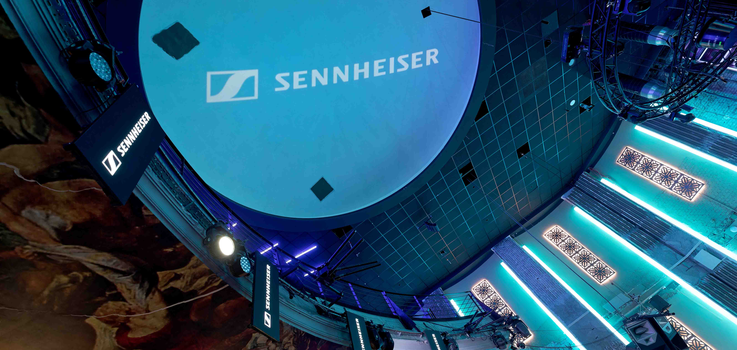Sennheiser Sound Expert Seminar EMEA 2024

Wedemark, June 2024 – At the end of April, more than 50 renowned sound engineers from across Europe joined the Sennheiser Sound Expert Seminar in Düsseldorf, Germany. The two-day event was packed with workshops, with a particular focus on professional digital wireless including the new WMAS wideband technology. A dedicated “Experience Room” provided the engineers with an opportunity to listen in to WMAS prototypes and create their own in-ear mixes with this new technology.

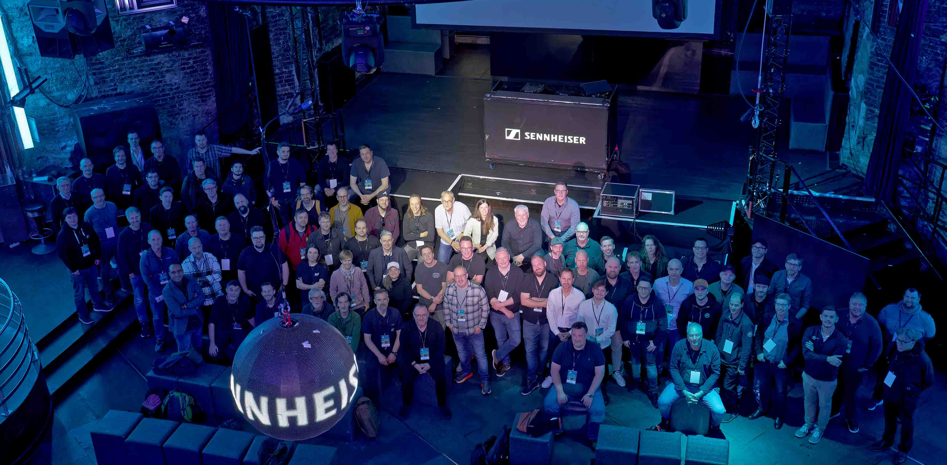
More than 50 sound experts joined the event

“The Sennheiser team was delighted to again welcome expert guests from across the EMEA region,” said Chris Kopp, project manager of the Sound Expert Seminar. “Offering a platform where engineers and producers can network, exchange ideas, and find out about the latest industry developments was a key ingredient of this seminar. However, what was decidedly more important was our guests, whose expertise and enthusiasm made the seminar into something very special.”

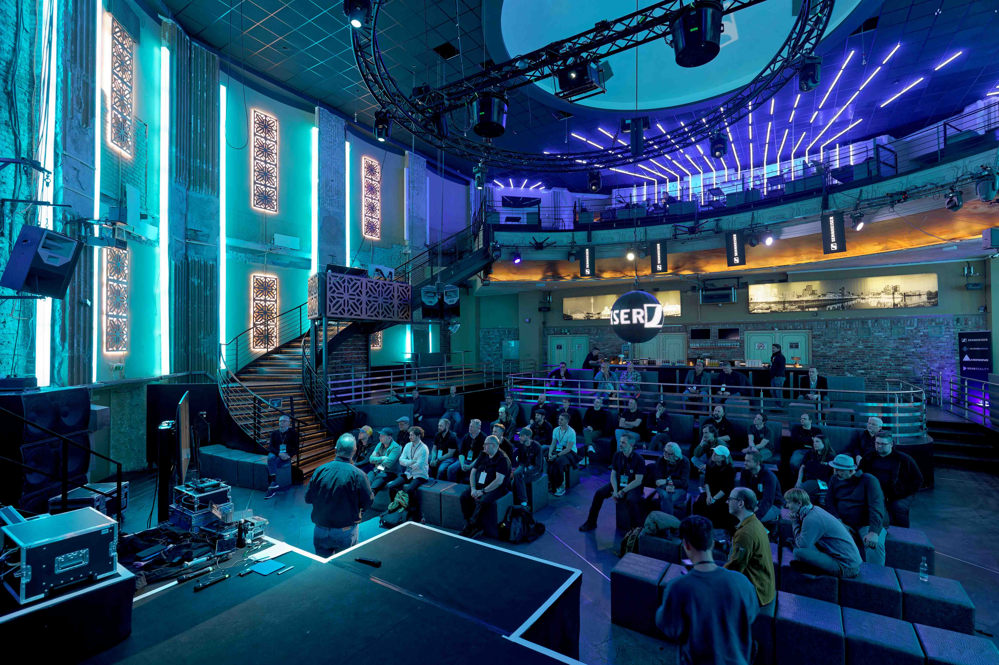
The seminar put a special focus on digital wireless technology

Wireless and psychoacoustics
Members of Sennheiser’s application engineering team were on site to run the wireless workshops, sharing the latest tips and tricks and offering hands-on sessions with WMAS development prototypes. Using the bidirectional prototypes as IEMs only, engineers could experience the clarity of a low-latency digital IEM and do multitrack recordings of their own in-ear mixes on digital consoles to directly compare them with analogue IEMs.

In hands-on sessions, the guests could compare analogue and digital wireless IEM sound | 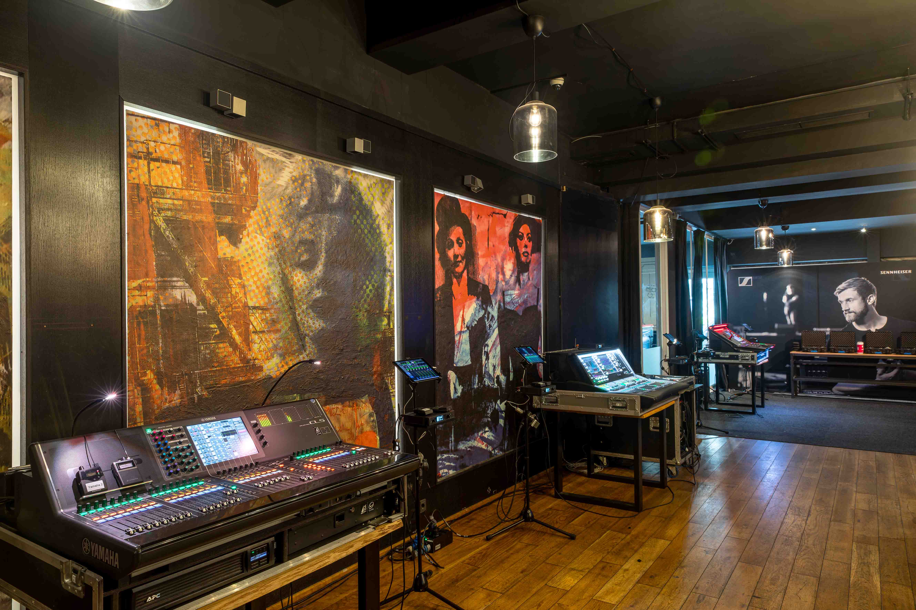

Immersive audio and captivating binaural audio samples were at the centre of Lasse Nipkow’s psychoacoustic workshop. Nipkow has been researching into applied psychoacoustics since 2010, and he has done both 3D recordings of classical music and dance music as well as sound design for animated movies.

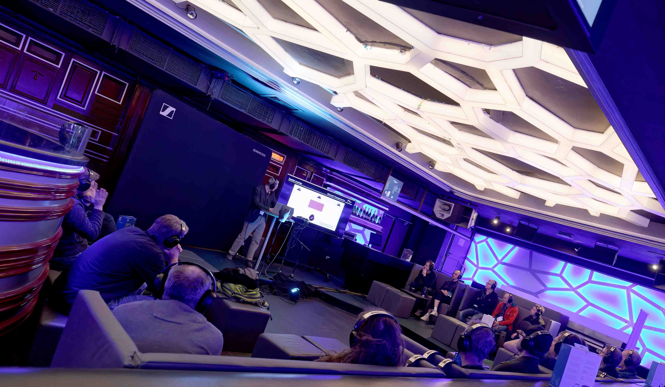 | The immersive audio and binaural session

A breeding ground for music
The roots of many national and international bands, in particular from the punk and electro scene, are in Düsseldorf. During a very special city tour (“The Sound of Düsseldorf”) participants learnt about “Die Toten Hosen”, “DAF” and “Kraftwerk”, and listened to audio samples by the bands.

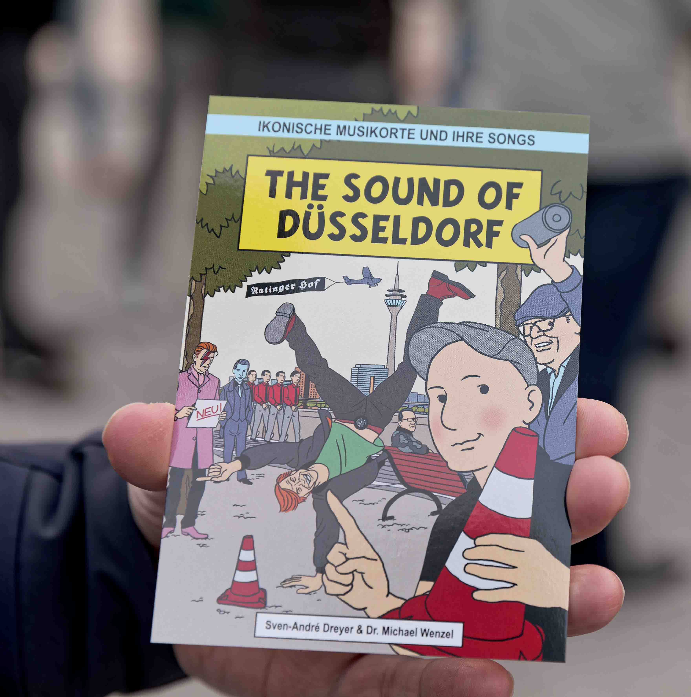 | The sound experts walked in the footsteps of Kraftwerk and other famous Düsseldorf bands

Some participant comments

“I was particularly excited about the long-awaited new WMAS digital wireless system – I was finally able to listen to the bidirectional bodypacks and was impressed by their sound quality. A game changer in the in-ear sector! I can hardly wait to do my first jobs with it and finally be able to offer this sound quality to my customers. There were also exciting and entertaining presentations and lots of nice little conversations on the side. All in all, a well-rounded event with a great supporting programme. Thank you, Sennheiser!”
Thomas Hofer, Monitor Engineer

“The Sound Experts Seminar was a fantastic opportunity not only to see some of the incredible emerging technologies from Sennheiser, Neumann and Merging, but also share ideas with esteemed colleagues from across the industry in a conducive environment. I’d really highly recommend anyone invited by Sennheiser to attend to do so.”
Phil Wright, Sound Designer and Mix Engineer

“The Sennheiser Sound Experts Seminar was excellent, this is exactly the kind of event that our industry needs. We are, essentially, a very small group of people in the professional audio world of Engineers and Designers. We should get together and talk, not only with manufacturers but with each other. I learned a lot both personally and professionally, a great experience. Bravo Sennheiser, leading the way. I cannot wait for the next one.”
Richard Brooker, Sound Designer/Engineer

“A total privilege to be invited to Sennheiser’s ‘Sound Experts Seminar’ - very impressed and excited to experience the next generation of RF solutions for live production. As demand for spectrum expands, while usable spectrum shrinks, Sennheiser have developed something game changing in terms of deployment and quality that I’m really excited to see in action on the road. Huge thanks to Sennheiser and Kevin Gwyther-Brown for their hospitality.”
Chris Parker, Patchwork London

After two exciting and eventful days, the sound experts moved on – back to the concert halls and festival grounds in EMEA and beyond.

(Ends)

The high-resolution images accompanying this media release can be downloaded here.

About the Sennheiser brand
We live and breathe audio. We are driven by the passion to create audio solutions that make a difference. Building the future of audio and bringing remarkable sound experiences to our customers – this is what the Sennheiser brand has represented for more than 75 years. While professional audio solutions such as microphones, meeting solutions, streaming technologies and monitoring systems are part of the business of Sennheiser electronic GmbH & Co. KG, the business with consumer devices such as headphones, soundbars and speech-enhanced hearables is operated by Sonova Holding AG under the license of Sennheiser.

www.sennheiser.com
www.sennheiser-hearing.com

Global Pro Audio Press Contact
Stephanie Schmidt
stephanie.schmidt@sennheiser.com
+49 (5130) 600 – 1275

